Employees being exposed to the COVID 19 virus whilst at work and carrying out their day to day duties | Infection being spread to people who are nearby (within 2m) or possibly being inhaled into the lungs  Someone becoming infected by touching a surface, object or the hand of an infected person that has been contaminated with respiratory secretions and then touching their own mouth, nose, or eyes (such as touching a door knob or shaking hands then touching their own face) | 4 | 2 | 8 | Employees  Contractors  Agency Staff  Customers  Service Users | - COVID-19  There is currently no vaccine to prevent COVID-19. The best way to prevent infection is to avoid being exposed to the virus.  The official information plus further guidance regarding what to do whilst at home can be found here https://www.gov.uk/government/publications/covid-19-stay-at-home-guidance/stay-at-home-guidance-for-people-with-confirmed-or-possible-coronavirus-covid-19-infection  - Action to take if you are displaying symptoms or test positive:  EVERYONE MUST follow the stay at home guidance if they have symptoms consistent with the coronavirus infection (e.g. a new persistent cough, high temperature or loss of taste / smell) or someone else in their household has symptoms. If you develop symptoms whilst on site, YOU MUST  - Return home immediately  - Avoid touching anything  - Cough or sneeze into a tissue and put it in a bin, if no tissues are available cough and sneeze into the crook of your elbow.  - Arrange to take a test  If you test positive you must notify an appropriate manager immediately and self isolate for 10 days. A self isolation note should be sent to your Supervisor, the link for the form is as follows https://111.nhs.uk/isolation-note/  The NHS test and trace service has been established to minimise community transmission of COVID-19. It is designed to:  - ensure that anyone who develops symptoms of COVID-19 can quickly be tested to find out if they have the virus  - help trace close recent contacts of anyone who tests positive for COVID-19 and, if necessary, notify them that they should self-isolate at home to help stop the spread of the virus  Therefore, if you have had close recent contact with someone who has COVID-19, you must self-isolate if the NHS test and trace service advises you to do so.  Close contact excludes circumstances where PPE is being worn in accordance with current guidance on infection, prevention and control.  - Action to take if someone within your home is self-isolating:  If someone within your home is self isolating with symptoms of Coronavirus all family members must self isolate for 14 days. You should arrange to be tested and a self isolation note should be sent to your Supervisor, the link for the form is as follows https://111.nhs.uk/isolation-note/.  - If you consider yourself to be in a high risk category  You should follow the official government guidelines and ensure the CHIPS system is updated with any medical information that we should be aware of. You should take precautions as per the government’s official advice to reduce the risk of contracting the virus and let your Supervisor know should you have any concerns.  Guidelines to working safely and PPE are included below.  - What visits are we completing to customer sites:  - All emergency, urgent, routine and planned works to both the internal and external of properties.  - Gas servicing and repairs.  - Electrical Periodic Testing  - Mutual exchanges  - Void works  - Process for completing internal/external works/servicing:  - Customers should be contacted by phone prior to any appointments and asked whether they have any symptoms of COVID-19 are self isolating or have any vulnerability that could make them more at risk.  - If the customer does not answer the phone, knock on the door and move back at least 2 metres from the door area and ask the customer directly. Symptoms of Coronavirus include:  - a new continuous cough and/or high temperature of 37.8C (100F) or loss of smell or taste.  - Where there are no concerns, advise the customer that we are complying with the governments guidance on managing the risk of COVID-19, complete the repair/gas service/electrical check using the following process:  - Apply hand sanitiser or wash hands before entering the property.  - Disposable gloves are also provided.  - Put on a face mask.  - Stay at least 2 meters away from the customer while speaking to them  - Ask the customer to move to a different area of the property from where you are working whilst you complete your work  - Avoid contact with surfaces and items that you do not need to come in to contact with. Wipe down any surfaces your may be touching and any tools/equipment after use.  - On leaving the property ensure you wash your hands or use sanitiser.  - Out of hours visits are being limited to genuine emergencies where there is real risk to property or life. ORCA are asking all customers if anyone is ill, showing symptoms or self isolating and will pass this on to anyone visiting the property.  - Shielding  Shielding came to an end on 1st August 2020. Works can be completed within properties where customers were previously shielding and safe working guidelines followed.  - Where Symptoms are Present, or a member of the household has tested positive or Customers are Self Isolating  Where a member of the household has COVID-19 or is self isolating, only genuine emergency repairs that are a risk to the customer or property will be completed.  Emergency Repairs  - If the customer advises that they are ill, have symptoms, have tested positive or are self-isolating when you have already arrived at a property, the appropriate PPE and guidelines for reducing the risk of exposure to the virus are below. If you are in doubt as to whether the repair should go ahead or you have any concerns, please contact a Supervisor.  - You must contact the contact centre on 0800 169 2407 with the property details whether you completed a visit or not so the system can be updated. You will need to ask the customer if they are self-isolating to keep themselves safe or have symptoms of Coronavirus.  Gas Servicing  - The gas service must not be completed if the customer has symptoms of COVID-19 or has tested positive.  - If the customer does not allow access due to them self-isolating the Gas service checks will be rescheduled for in 10 or 14 days time or at the appropriate time.  - Where the gas service has not been completed as the customer will not allow access the reason for this must be included on the no access card e.g. self isolating 10 to 14 days. This will be recorded against the gas service appointment.  - You must contact the contact centre on 0800 169 2407 with the property details whether you completed a visit or not so the system can be updated. You will need to ask the customer if they are self-isolating to keep themselves safe or have symptoms of Coronavirus.  - PPE Guidance for Emergency Repairs where household Self-Isolating/COVID  Ensure that customers are in a different part of the house whilst work is completed.  - The following process should be followed to complete the repair:  - Wear a face mask, eye goggles, disposable overalls and disposable gloves.  - Wash/sanitise hands  - Put on overalls  - Put on facemask – upper straps on the crown of your head and lower strap at the nape of your neck  - Put on eye protection  - Put on gloves  - A surgical mask or disposable respirator mask can be worn without a face fit test in a communal or client area observing 2m social distancing advice, if the work does not involve the creation of or exposure to construction related dust.  - A fluid repellent mask would need to be worn if you were to be in direct contact with a customer or within 2 metres of a customer with a cough. This should never need to be the case in the context of carrying out a repair/gas service.  - Ask customers to stay in another room  - Touch as little as possible e.g. door handles etc.  - Wipe down surfaces before commencing work  - Complete the repair, wipe surfaces and leave the property  - Remove PPE:  - Remove overalls without touching your own clothes  - Remove gloves by grasping the outside of the glove with your other hand, peel off. Hold the removed glove in the remaining gloved hand. Peel the remaining glove off over the first glove and discard into a bag  - Clean/sanitise hands  - Remove eye protection and clean/sanitise goggles  - Clean/sanitise hands  - Remove face mask  - Clean/Sanitise hands  - Dispose of all disposable PPE in a bag and tie it up, dispose as soon as possible into another bag.  - Wipe down any tools or equipment that have been used  - Wash hands and sanitise  - Disposing of Used PPE  All PPE should be bagged and can then be put in another bag in the bag of the van. After 72 hours the bag should be tied and this can be thrown into the general waste skip. Only PPE that has been used in direct contact with a customer or within 2 metres of a customer who has COVID-19 symptoms would need to be disposed of as clinical waste. There are yellow bags at Burnham Gate should these be required. If these are used, please let Dave Ramsbottom or another Supervisor know so that they can be disposed of appropriately.  - Lone Working  - Ensure loan worker devices are charged and on your person at all times.  - Follow loan worker guidance  - Safe Operating Procedures  Further guidance is provided in document CH(D)02.01 on safe working practices on site across all work areas. This includes reference to the guidance on hierarchy of control CH(D)01.01.  - Travelling in Vehicles  Should it be necessary for more than 1 person to travel in 1 vehicle then the process outlined in document CH(D)02.01 should be followed and the vehicle cleaning checklist followed. Please ensure that masks are worn by all people travelling in the same vehicle at all times.  - Safe Guarding  With the increase in people being at home, there is a high chance that domestic abuse incidents will increase. If you have any concerns about anything you see whilst visiting a customers home, we have a duty of care to report it no matter how insignificant it may seem at the time. Please email: sunflower@calico.org.uk  Please include a description of your concerns and a complex case officer will contact you to discuss this further and decide on the appropriate action to take. The reporting person will remain anonymous.  - General Housekeeping  Ensure that good housekeeping and hygiene is practiced in terms of cleaning cutlery, cups and canteen areas as well as individual desks and workstations. Consideration to cleaning shared vehicle interiors should also be made.  Refer to https://www.gov.uk/government/publications/guidance-to-employers-and-businesses-about-covid-19/guidance-for-employers-and-businesses-on-covid-19 For further information  - General Advice:  Public Health England (PHE) recommends that the following general cold and flu precautions are take to help prevent people from catching and spreading COVID-19.  - Cover your mouth and nose with a tissue or your sleeve (not your hands) when you cough or sneeze. See Catch it, Bin it, Kill it  - Put used tissues in the bin straight away  - Wash your hands with soap and water often. Use hand sanitiser gel if soap and water are not available. See hand washing guidance.  - Try to avoid close contact with people who are unwell  - Clean and disinfect frequently touched objects and surfaces  - Do not touch your eyes, nose or mouth if your hands are not clean. | 6

Providing the recommendations are followed and the training and instructions provided then the risks can be reduced to acceptable levels.
Overall Risk Rating: 6 | Date of Next Review: ONGOING AS ADVICE IS UPDATED

PPE Required for Task (tick/complete as appropriate – Refer to Control Measures over page making specific)
Hard Hat |  | Ear Protection |  | Welding Helmet
Safety Footwear | Y | Goggles | Y | Respirator (Type) | Surgical or disposable respirator
High Vis Vest | Y | Overalls | As appropriate | Gloves (enter type) | As appropriate
Gas Welding Goggles |  | Safety Spectacles |  | Other (specify type)
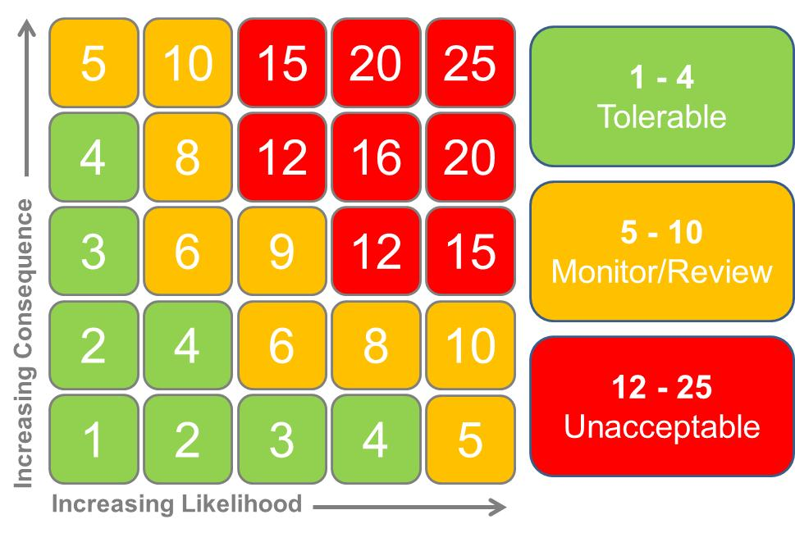
Col (A) - Likelihood of Injury or Hazard | Col (B) - Severity of Injury or Hazard | Who Could Be Affected
- Improbable - (Extremely Unlikely To Occur) | - Minor (No First Aid Required) | Operators
- Remote (Small Chance Of Occurring) | - Harmful (Minor First Aid Required) | Maintenance / Quality
- Occasional (Could Occur Sometime) | - Critical (Serious Fractures, Burns, L.T.A.) | Contractors
- Probable (Unsurprised If It Happened) | - Severe (Amputations, Loss Of Eyesight) | Visitors
- Frequent (Almost Certain To Happen) | - Catastrophic ( Fatality, Explosions Etc) | Special Cases (Pregnant Worker/Young People Under 18)

